ASSIGNMENT-10

HALL TICKET NO :2403A54106

Code Review and Quality: Using AI to Improve Code
Quality and Readability

TASK#1:

Task Description #1 – Syntax and Logic Errors
Task: Use AI to identify and fix syntax and logic errors in a faulty
Python script.
Sample Input Code:
# Calculate average score of a student
def calc_average(marks):
total = 0
for m in marks:
total += m
average = total / len(marks)
return avrage # Typo here
marks = [85, 90, 78, 92]
print("Average Score is ", calc_average(marks)
Expected Output:
• Corrected and runnable Python code with explanations of the
fixes.

PROMPT:
You are given a faulty Python script with syntax and logic errors. Your task is to identify the errors, explain them, and provide the corrected code.
Identify and fix syntax and logic errors in the given Python code.
Explain what mistakes were present and how you corrected them.
Provide the corrected, runnable code.
Show the final program output for the given input.

CODE: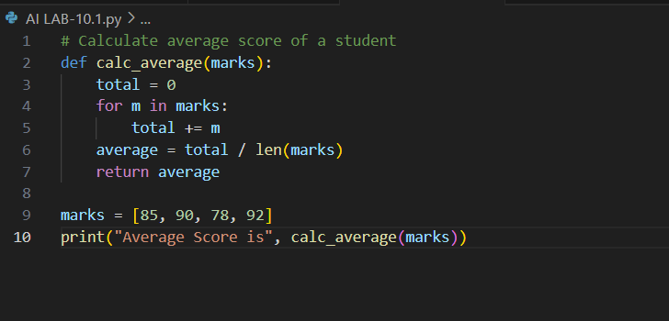

OUTPUT: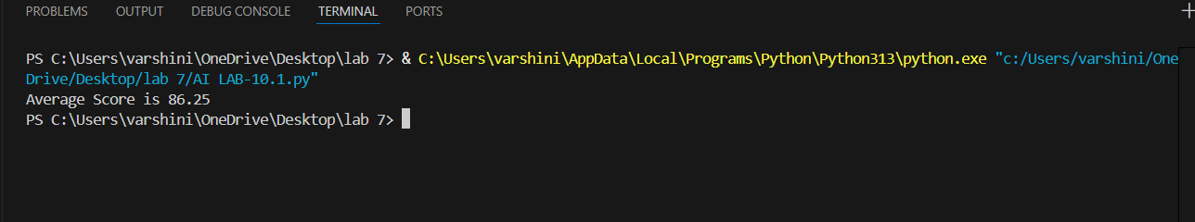

FIXES:
- Added proper indentation inside the function.
- Fixed the typo (avrage → average).
- Added the missing closing parenthesis in print().

OBSERVATION:
- The given Python code was intended to calculate the average of a list of marks.
- The code had syntax and logic errors:
- Missing indentation inside the function.
- Typo in variable name (avrage → average).
- Missing closing parenthesis in the print() statement.
- Due to these errors, the program could not run successfully

TASK#2
Task Description #2 – PEP 8 Compliance
Task: Use AI to refactor Python code to follow PEP 8 style guidelines.
Sample Input Code:
def area_of_rect(L,B):return L*B
print(area_of_rect(10,20))
Expected Output:
• Well-formatted PEP 8-compliant Python code.

PROMPT:
Refactor the given Python code to follow PEP 8 style guidelines.
Identify any violations of PEP 8 (naming, spacing, formatting).
Provide the corrected, PEP 8–compliant version of the code.
Show the final output of the refactored code.

CODE:
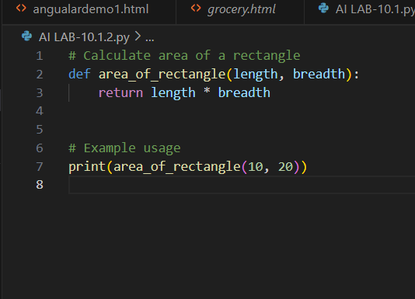

OUTPUT:
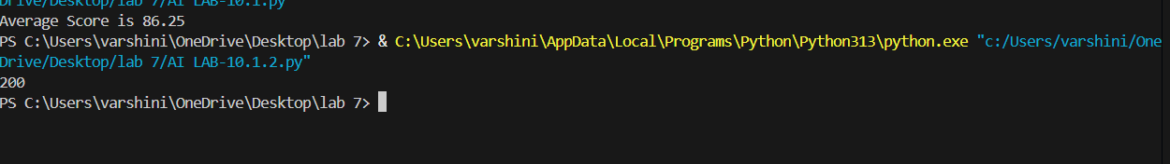

FIXES AND EXPLANATION:
- Changed function name to area_of_rectangle for clarity.
- Renamed parameters L → length, B → breadth.
- Moved return statement to a separate, indented line.
- Added blank lines for readability (PEP 8 recommends 2 lines before top-level functions).
- Added a short comment for clarity.
OBSERVATION :
The given Python code calculates the area of a rectangle but does not follow PEP 8 guidelines:
- The function definition and return statement were written on the same line, which is against PEP 8.
- The parameter names L and B are single uppercase letters, which are not descriptive. PEP 8 recommends using lowercase descriptive names.
- There was no spacing or blank lines to improve readability.
After refactoring:
- The function name was changed to area_of_rectangle (clearer and descriptive).
- Parameters were renamed to length and breadth.
- The return statement was placed on a separate indented line.
Blank lines and comments were added for readability

TASK#3:
Task: Use AI to make code more readable without changing its logic.
Sample Input Code:
def c(x,y):
return x*y/100
a=200
b=15
print(c(a,b))
Expected Output:
• Python code with descriptive variable names, inline comments,
and clear formatting.

PROMPT:
Refactor the given Python code to improve its readability without changing its logic.
Use descriptive variable and function names, proper formatting, and inline comments.
Ensure the code remains simple, clear, and easy to understand.
CODE: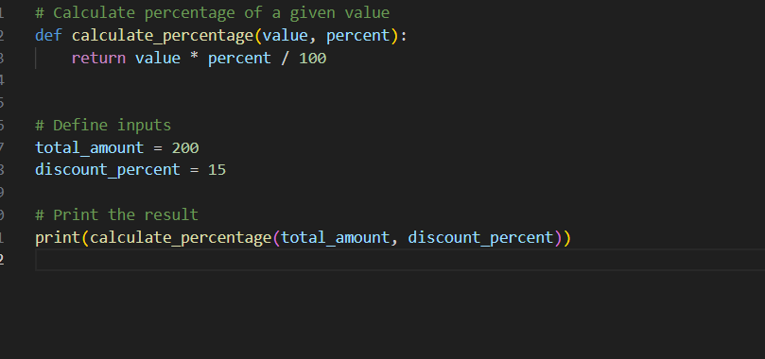

OUTPUT:
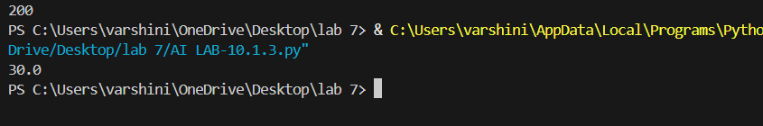

FIXES AND EXPLANATION:
- Renamed function c → calculate_percentage for clarity.
- Changed parameters x, y → value, percent (self-explanatory).
- Changed variables a, b → total_amount, discount_percent.
- Added comments to explain function and code steps.
- Applied proper formatting with blank lines.

OBSERVATION:
1. Original code worked correctly but lacked readability.
2. Non-descriptive names and missing comments made it hard to understand.
• After enhancement, the code is clear, well-structured, and beginner-friendly, while producing the same

TASK#4:
Task Description #4 – Refactoring for Maintainability
Task: Use AI to break repetitive or long code into reusable functions.
Sample Input Code:
students = ["Alice", "Bob", "Charlie"]
print("Welcome", students[0])
print("Welcome", students[1])
print("Welcome", students[2])
Expected Output:Modular code with reusable functions.

PROMPT:
Refactor the given Python code to remove repetition and improve maintainability.
Break long or repetitive code into reusable functions.
Ensure the refactored code is modular, clean, and scalable

CODE:
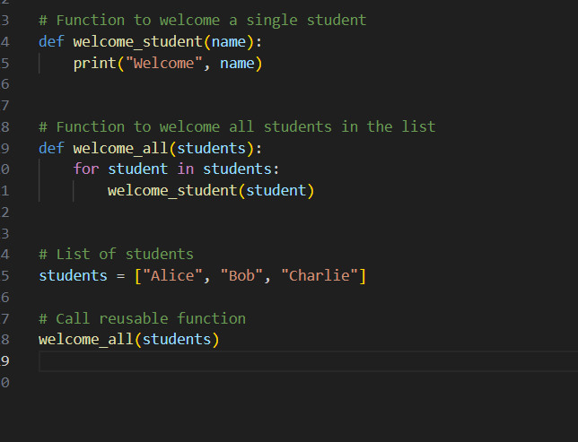

OUTPUT:
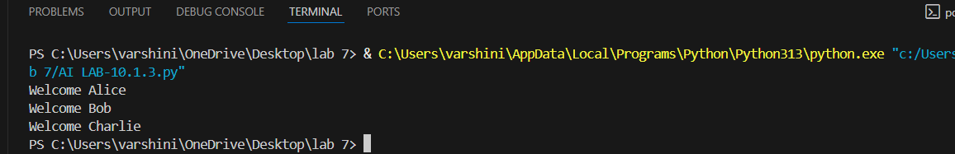

FIXES AND EXPLANATION:
- Created a reusable function welcome_student(name) for a single greeting.
- Added a loop inside another function welcome_all(students) to handle multiple students.
- Removed repetition → now code is modular, reusable, and easy to extend.

OBSERVATION:
- Created a reusable function welcome_student(name) for a single greeting.
- Added a loop inside another function welcome_all(students) to handle multiple students.
- Removed repetition → now code is modular, reusable, and easy to extend.

TASK#5:
Task: Use AI to make the code run faster.
Sample Input Code:
# Find squares of numbers
nums = [i for i in range(1,1000000)]
squares = []
for n in nums:
squares.append(n**2)
print(len(squares))
Expected Output:
• Optimized code using list comprehensions or vectorized
operations.

PROMPT :

Optimize the given Python code to make it run faster.
Replace inefficient loops with list comprehensions or vectorized operations.
Ensure the optimized code produces the same output.

CODE:

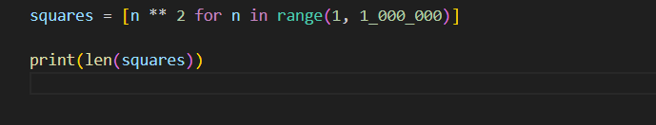

OUTPUT:
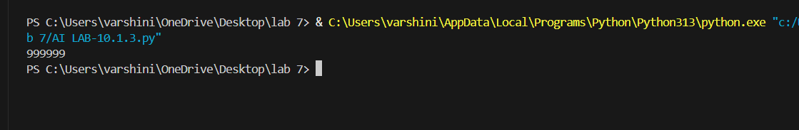

FIXES AND EXPLANATION:
- Replaced loop + append() with a list comprehension, which is more efficient in Python.
- Used range() directly inside comprehension to avoid storing nums separately.
- Optionally, NumPy vectorization makes it even faster for very large datasets

OBSERVATION:
1. Original code worked but was slower due to repeated looping and appending.
2. Refactored code with list comprehension is more Pythonic, concise, and efficient.
3. With NumPy, performance improves further due to C-level optimizations

TASK#6:
Task: Use AI to simplify overly complex logic.
Sample Input Code:
def grade(score):
if score >= 90:
return "A"
else:
if score >= 80:
return "B"
else:
if score >= 70:
return "C"
else:
if score >= 60:
return "D"
else:
return "F"
Expected Output:
• Cleaner logic using elif or dictionary mapping.

PROMPT:
Simplify the given Python code that uses overly nested if-else statements.
Refactor it using elif or a dictionary mapping for clarity.
Ensure the logic and output remain the same.

CODE:
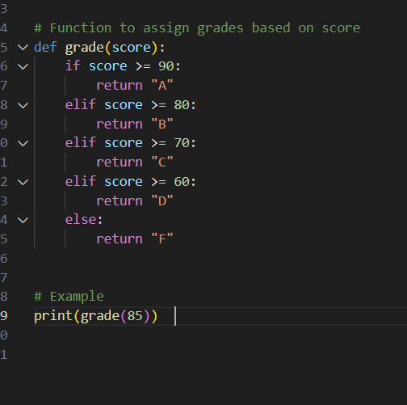

OUTPUT:
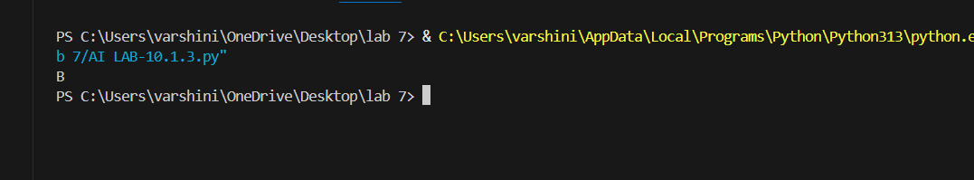

FIXES AND EXPLANATION:
- Replaced deep nested if-else with clean elif ladder.
- Optionally used a dictionary mapping with ranges for flexibility.
- Code is now shorter, more readable, and easier to maintain.

OBESERVATION:
- Original code worked but was overly complex due to nesting.
- Using elif simplified the flow and avoided redundancy.
- Dictionary mapping provides a scalable approach if grading rules change in future.
- Final output remains correct (e.g., grade(85) → "B").

